# [375. 猜数字大小 II](https://leetcode-cn.com/problems/guess-number-higher-or-lower-ii/)

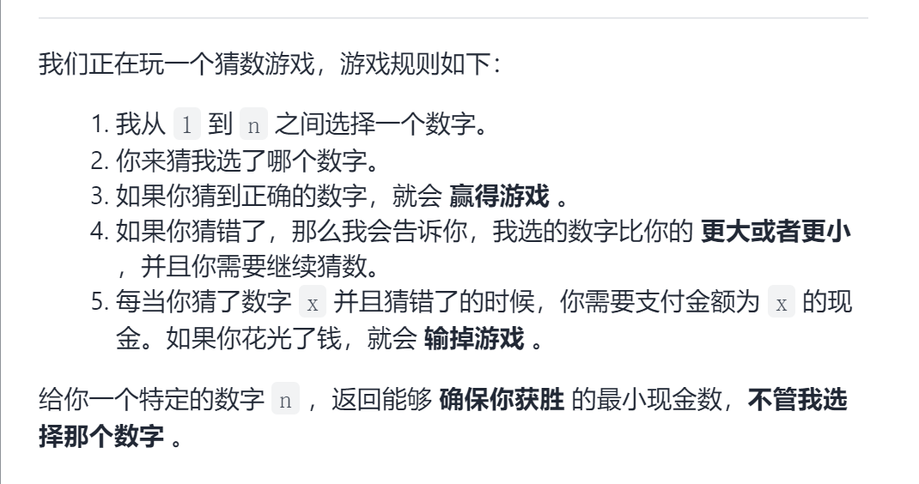

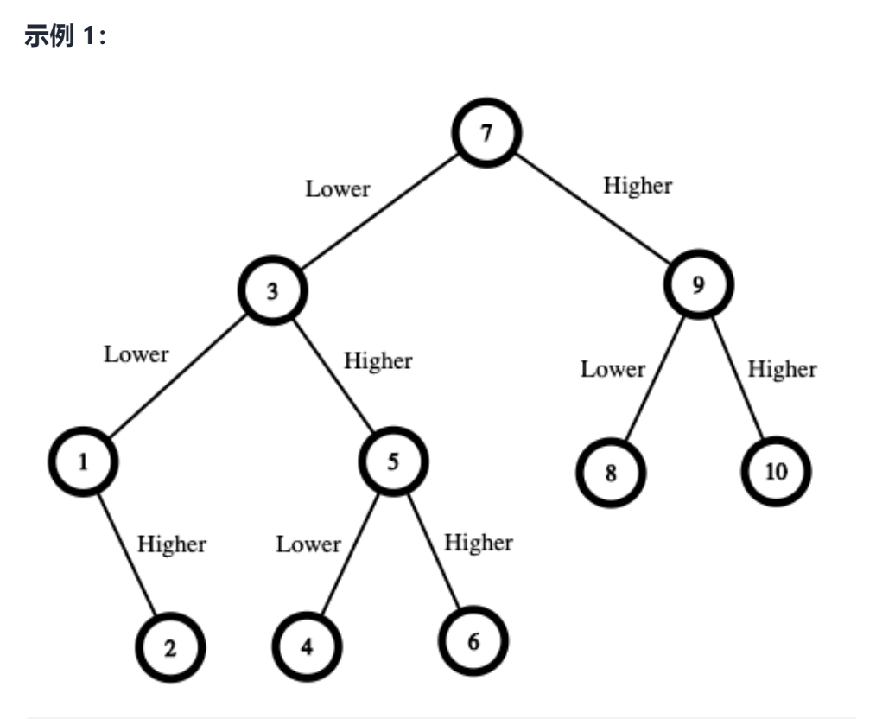

## 题目分析：

* **万物皆可dp**
* 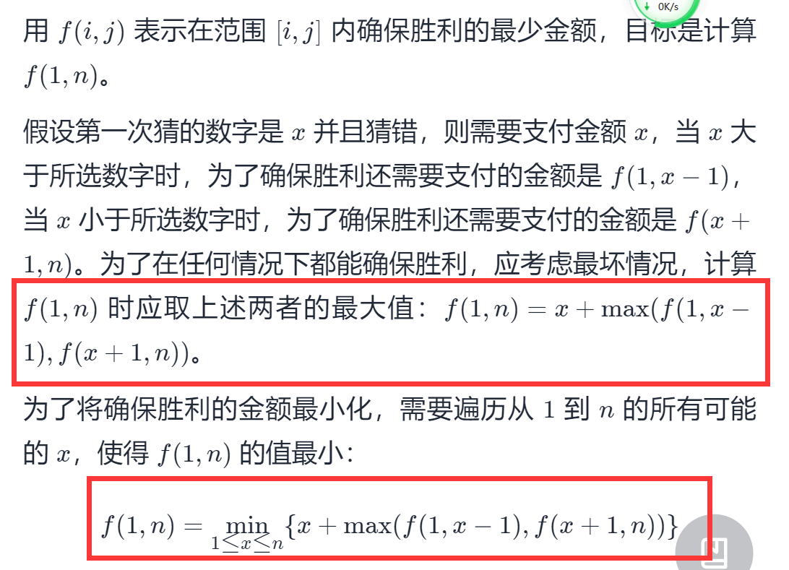
* **书写代码时注意遍历顺序：根据状态转移方程确定，而不是感觉**
* class Solution {  
  public:  
   int getMoneyAmount(int n) {  
   vector<vector<int>> f(n+1,vector<int>(n+1));  
   for (int i = n - 1; i >= 1; i--) {  
   for (int j = i + 1; j <= n; j++) {  
   int minCost = INT_MAX;  
   for (int k = i; k < j; k++) {  
   int cost = k + max(f[i][k - 1], f[k + 1][j]);  
   minCost = min(minCost, cost);  
   }  
   f[i][j] = minCost;  
   }  
   }  
   return f[1][n];  
    
   }  
  };  
    
  作者：LeetCode-Solution  
  链接：https://leetcode-cn.com/problems/guess-number-higher-or-lower-ii/solution/cai-shu-zi-da-xiao-ii-by-leetcode-soluti-a7vg/  
  来源：力扣（LeetCode）  
  著作权归作者所有。商业转载请联系作者获得授权，非商业转载请注明出处。